**MySQL :**

create table master(Name string, Age int,Email string,Phone string,Course string,Fee int,Discount int,Demo string,Status string) row format delimited fields terminated by ',' stored as textfile;

Load data local inpath ‘/home/cloudera/Desktop/master.txt’ into table master;

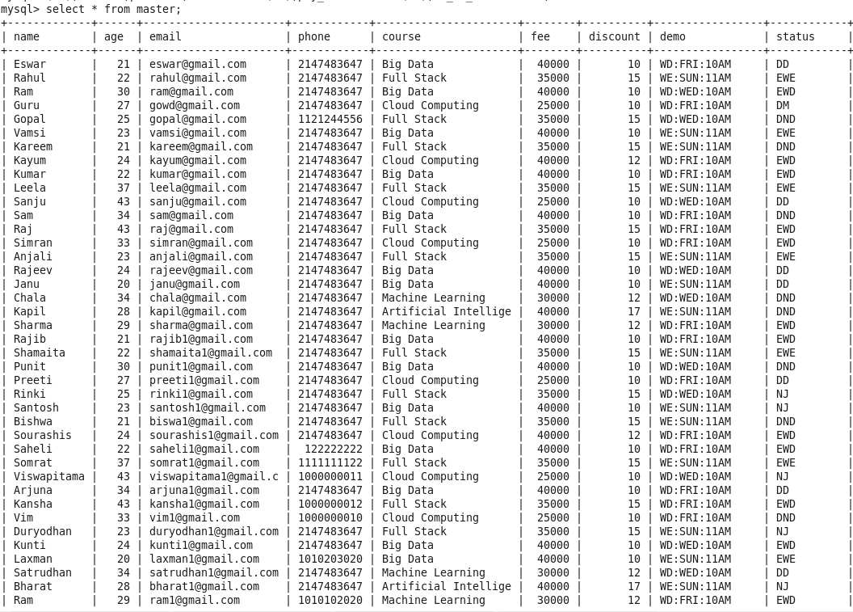

create table table4(name string,age int,email string,phone string,course string,fee int,paid int,mode string,pay_mode string,no_of_install int,due_date string) row format delimited fields terminated by ',' stored as textfile;

load data local inpath ‘/home/cloudera/Desktop/table4.txt’ into table payment;

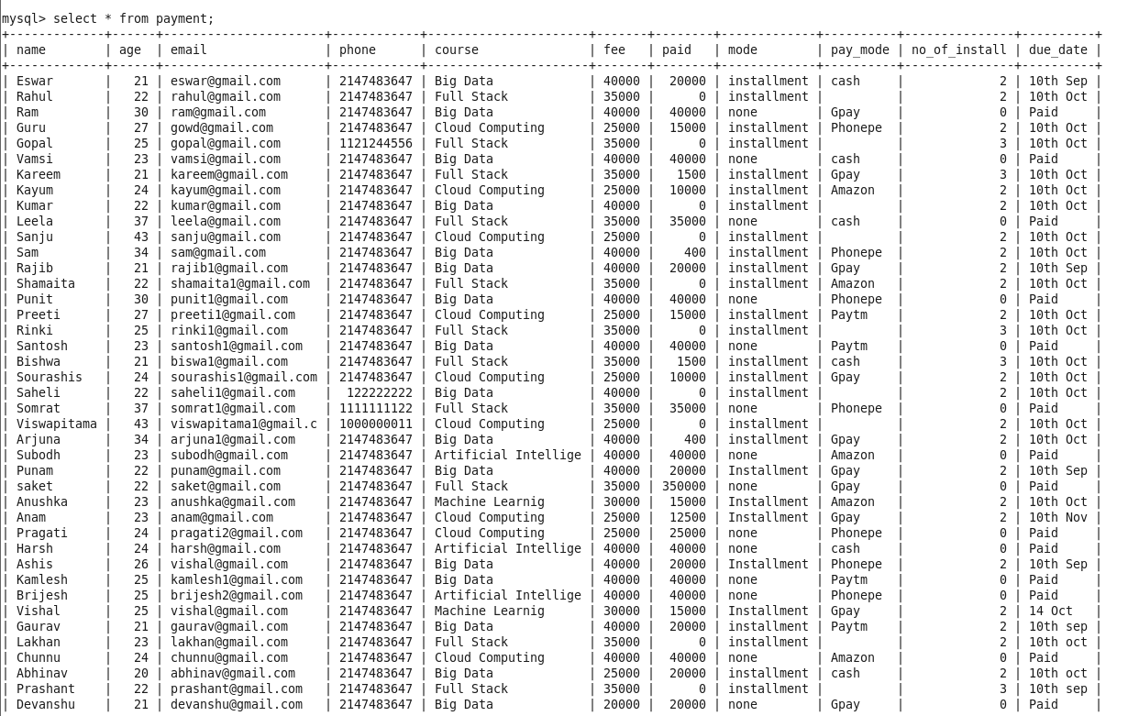

**Transferring tables from MySQL database to HDFS :**

sqoop import --connect jdbc:mysql://192.168.11.134/student --username root --password cloudera --table master --target-dir /user/cloudera/master/ -m 1

sqoop import --connect jdbc:mysql://192.168.11.134/student --username root --password cloudera --table payment --target-dir /user/cloudera/payment -m 1

**ACID PROPERTY IN HIVE**

---------------------

set hive.support.concurrency = true;

set hive.enforce.bucketing = true;

set hive.exec.dynamic.partition.mode = nonstrict;

set hive.txn.manager = org.apache.hadoop.hive.ql.lockmgr.DbTxnManager;

set hive.compactor.initiator.on = true;

=> create table enquiry(Name string, Age int,Email string,Phone string,Course string,Fee int,Discount int,Demo string,Status string) clustered by (Course) into 5 buckets stored as orc tblproperties('transactional'='true');

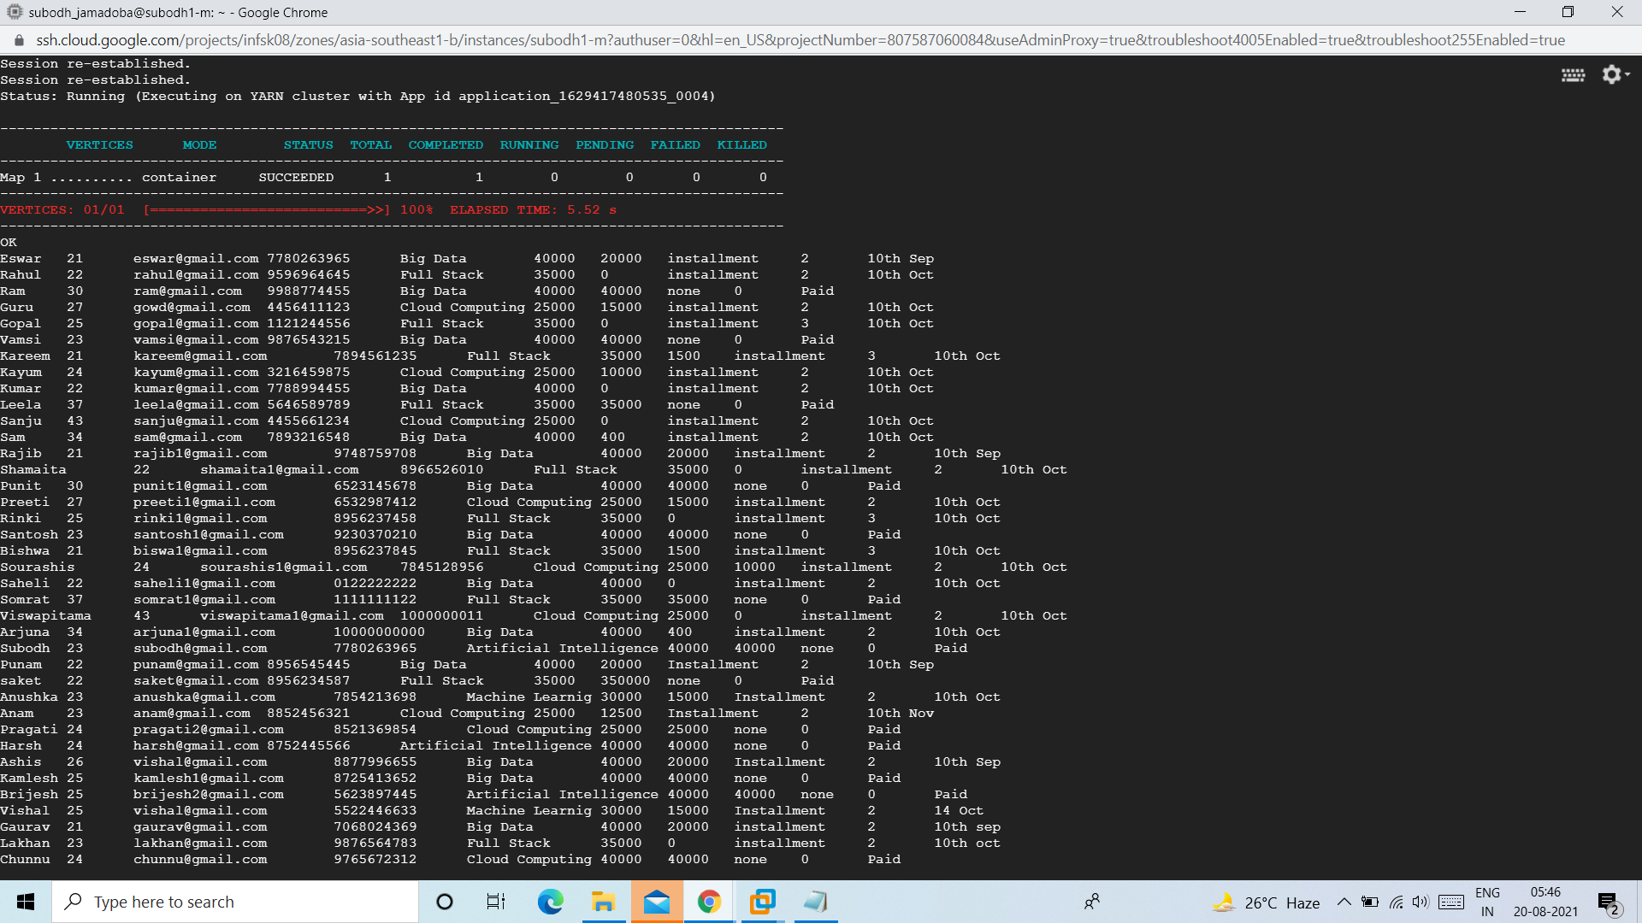

=>create table master(Name string, Age int,Email string,Phone string,Course string,Fee int,Discount int,Demo string,Status string) row format delimited fields terminated by ',' stored as textfile;

load data local inpath 'Master.txt' overwrite into table master;

insert into table enquiry select * from master;

Select * from enquiry;

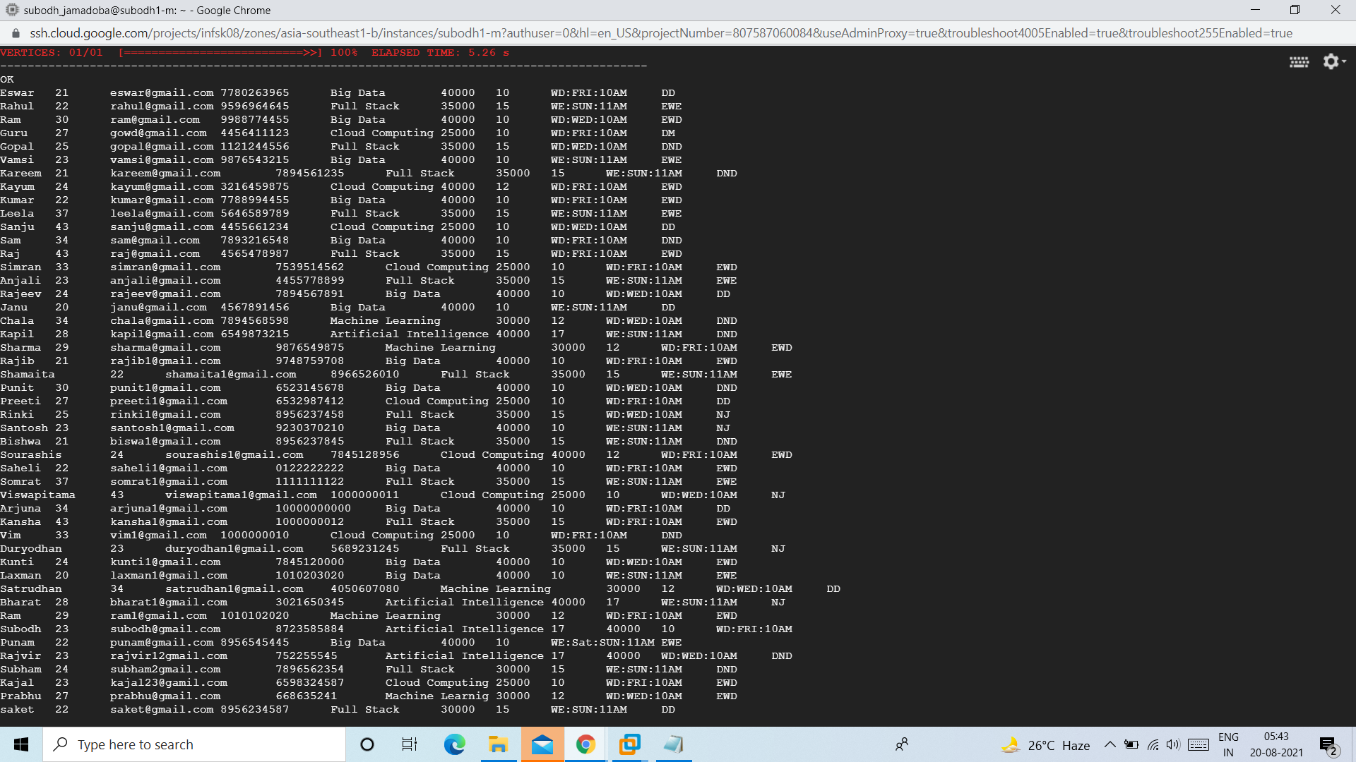

=>create table weekday_demo(name string,age int,email string,phone string,course string,demo_day string,demo_time string) clustered by (course) into 5 buckets stored as orc tblproperties('transactional'='true');

insert overwrite table weekday_demo select name,age,email,phone,course,substr(demo,4,3) as demo_day,substr(demo,8,4) as demo_time from enquiry where substr(demo,1,2)=='WD';

Select * from weekday_demo;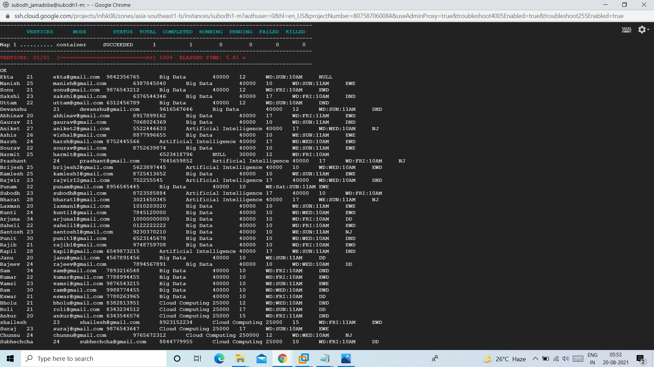

create table weekend_demo(name string,age int,email string,phone string,course string,demo_day string,demo_time string) clustered by (course) into 5 buckets stored as orc tblproperties('transactional'='true');

insert overwrite table weekend_demo select name,age,email,phone,course,substr(demo,4,3) as demo_day,substr(demo,8,4) as demo_time from enquiry where substr(demo,1,2)=='WE';

Select * from weekend_demo;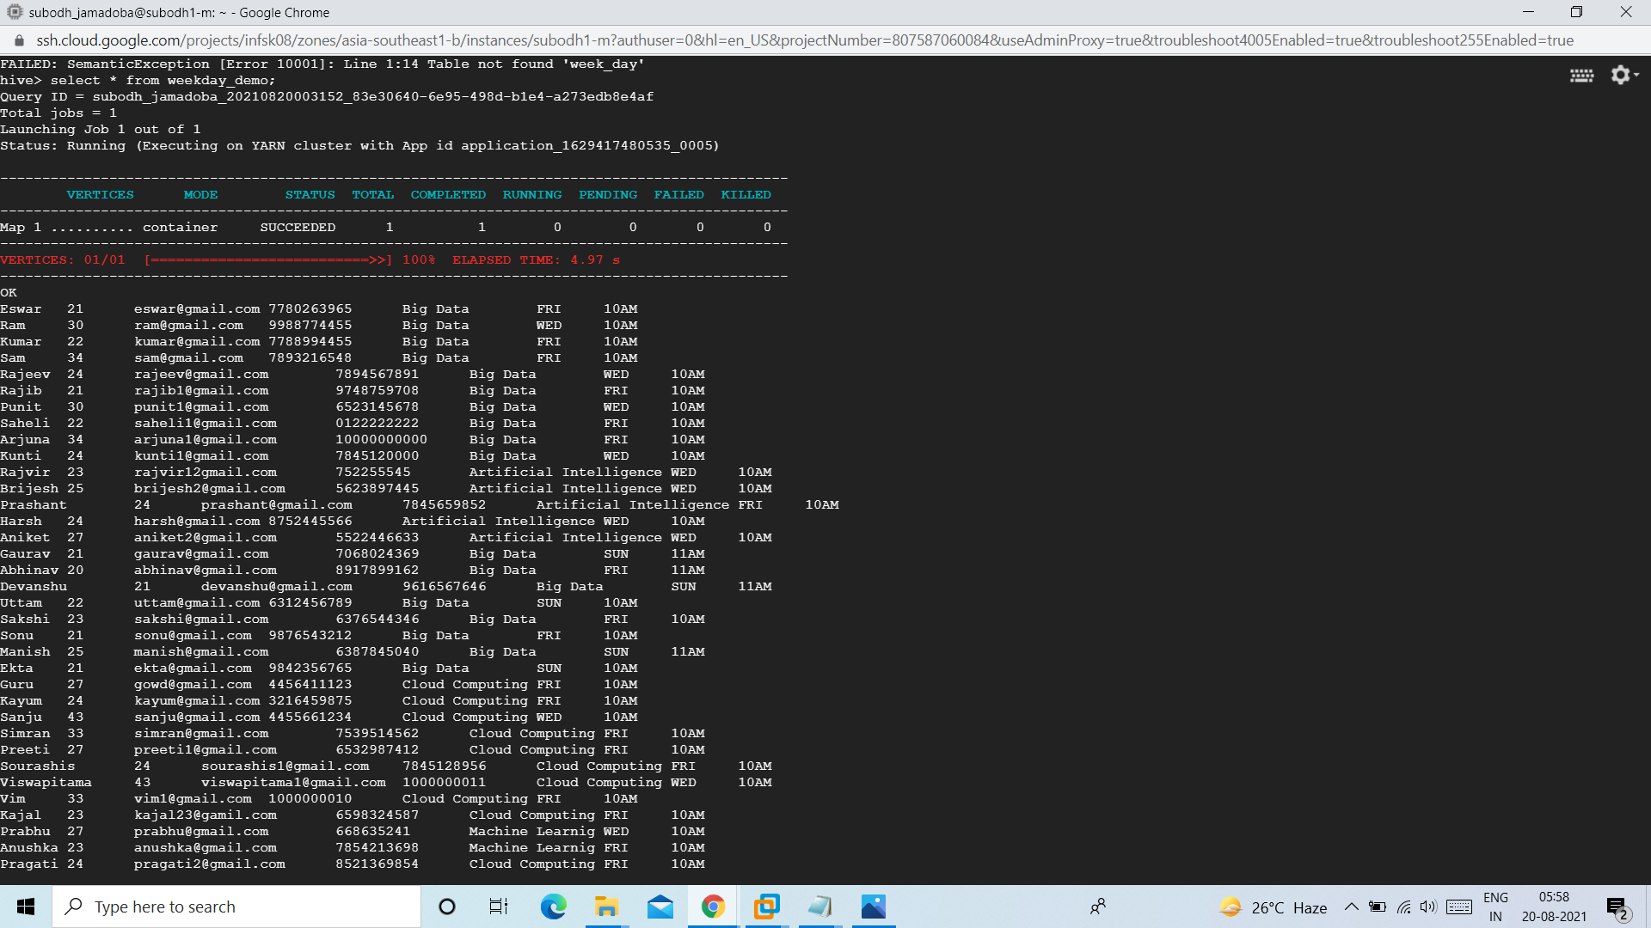

create table demo_not_done(name string,age int,email string,phone string,course string,week string,demo_day string,demo_time string) clustered by (course) into 5 buckets stored as orc tblproperties('transactional'='true');

insert overwrite table demo_not_done select name,age,email,phone,course,case when substr(demo,1,2)=='WD' then 'WEEKDAYS' when substr(demo,1,2)=='WE' then 'WEEKEND' end,substr(demo,4,3) as demo_day,substr(demo,8,4) as demo_time from enquiry where status='DND';

Select * from demo_not_done;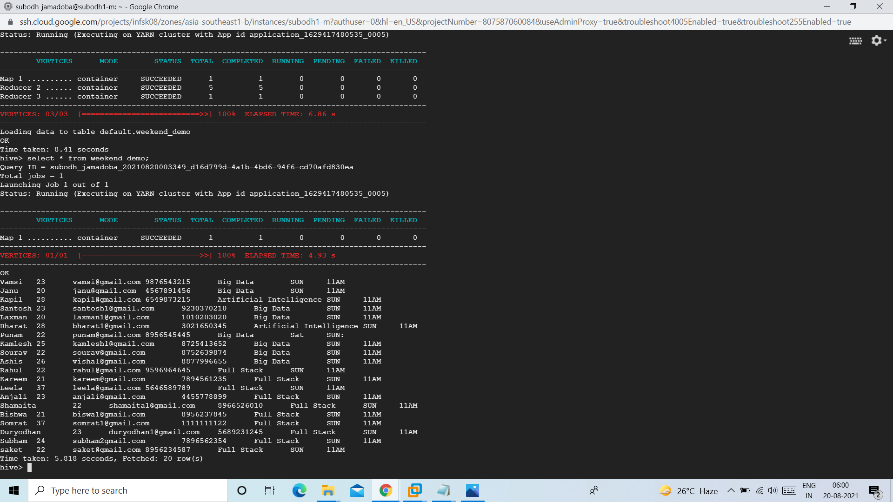

=>create table weekdays_joining(name string,age int,email string,phone string,course string,fee int,discount int) clustered by(course) into 5 buckets stored as orc tblproperties('transactional'='true');

insert overwrite table weekdays_joining select name,age,email,phone,course,fee,discount from enquiry where status='EWD';

Select * from weekdays_joining;

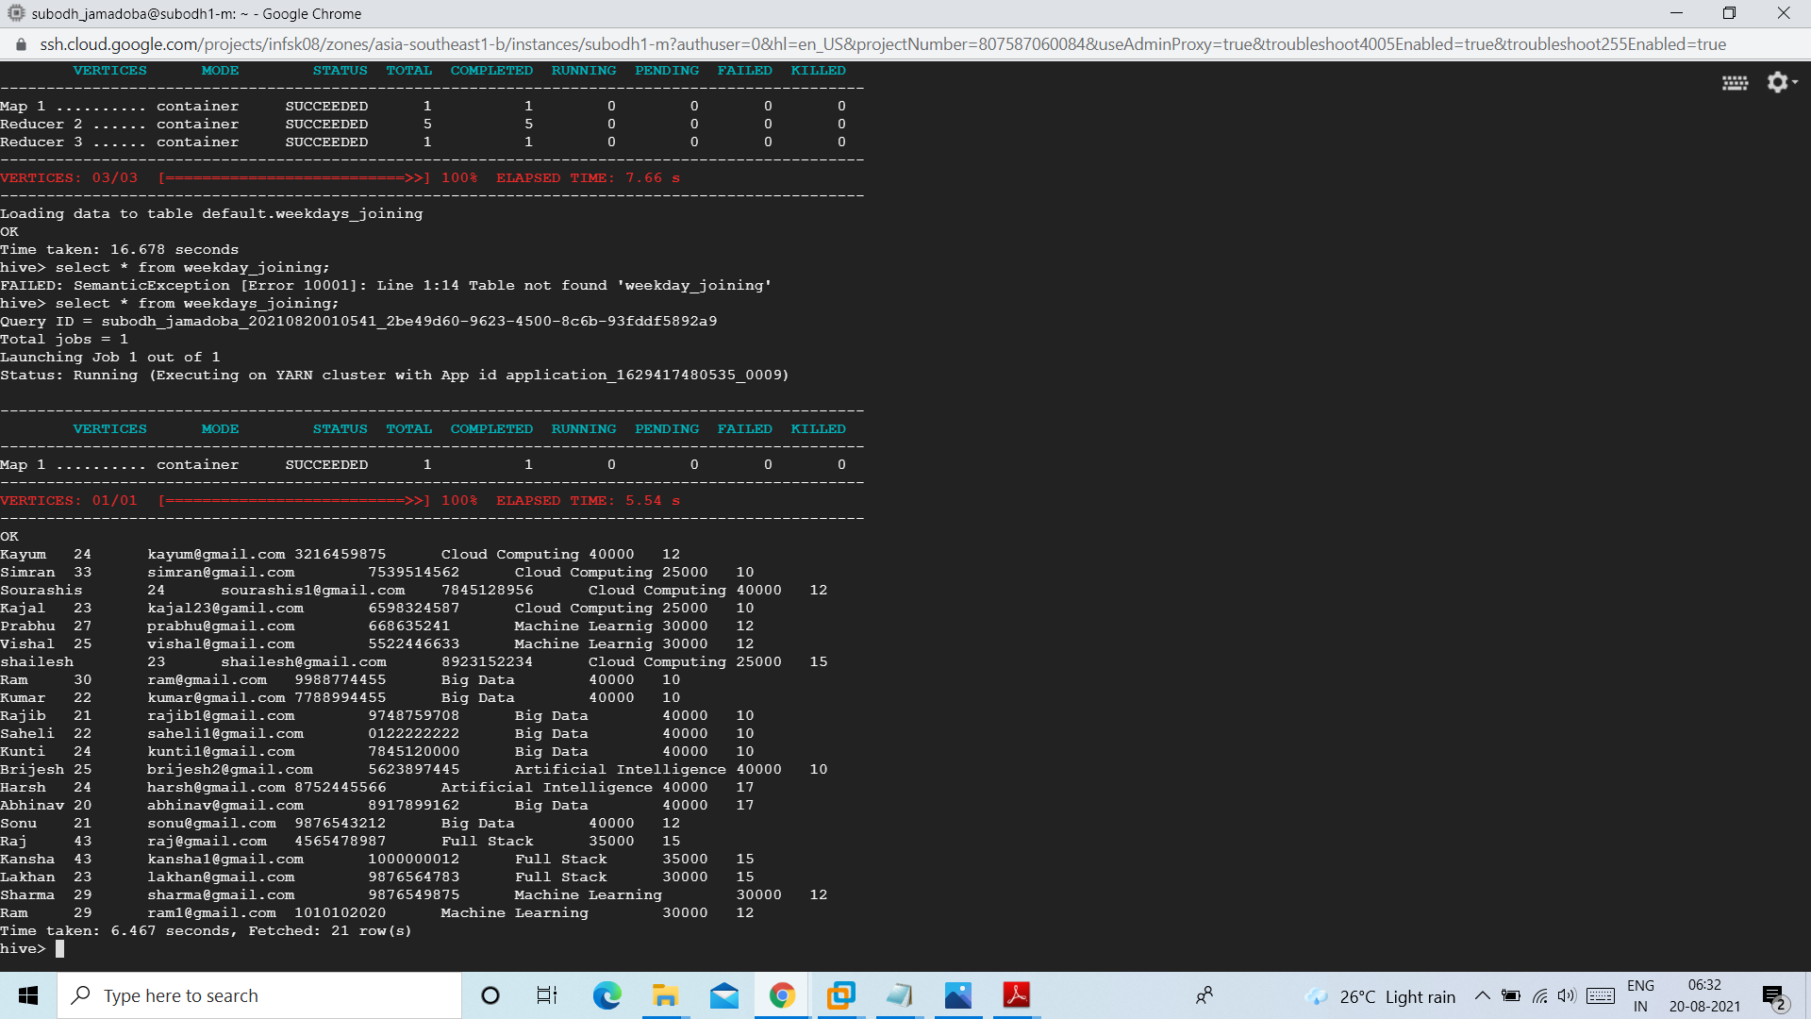

=>create table weekend_joining(name string,age int,email string,phone string,course string,fee int,discount int) clustered by(course) into 5 buckets stored as orc tblproperties('transactional'='true');

insert overwrite table weekend_joining select name,age,email,phone,course,fee,discount from enquiry where status='EWE';

Select * from weekend_joining;

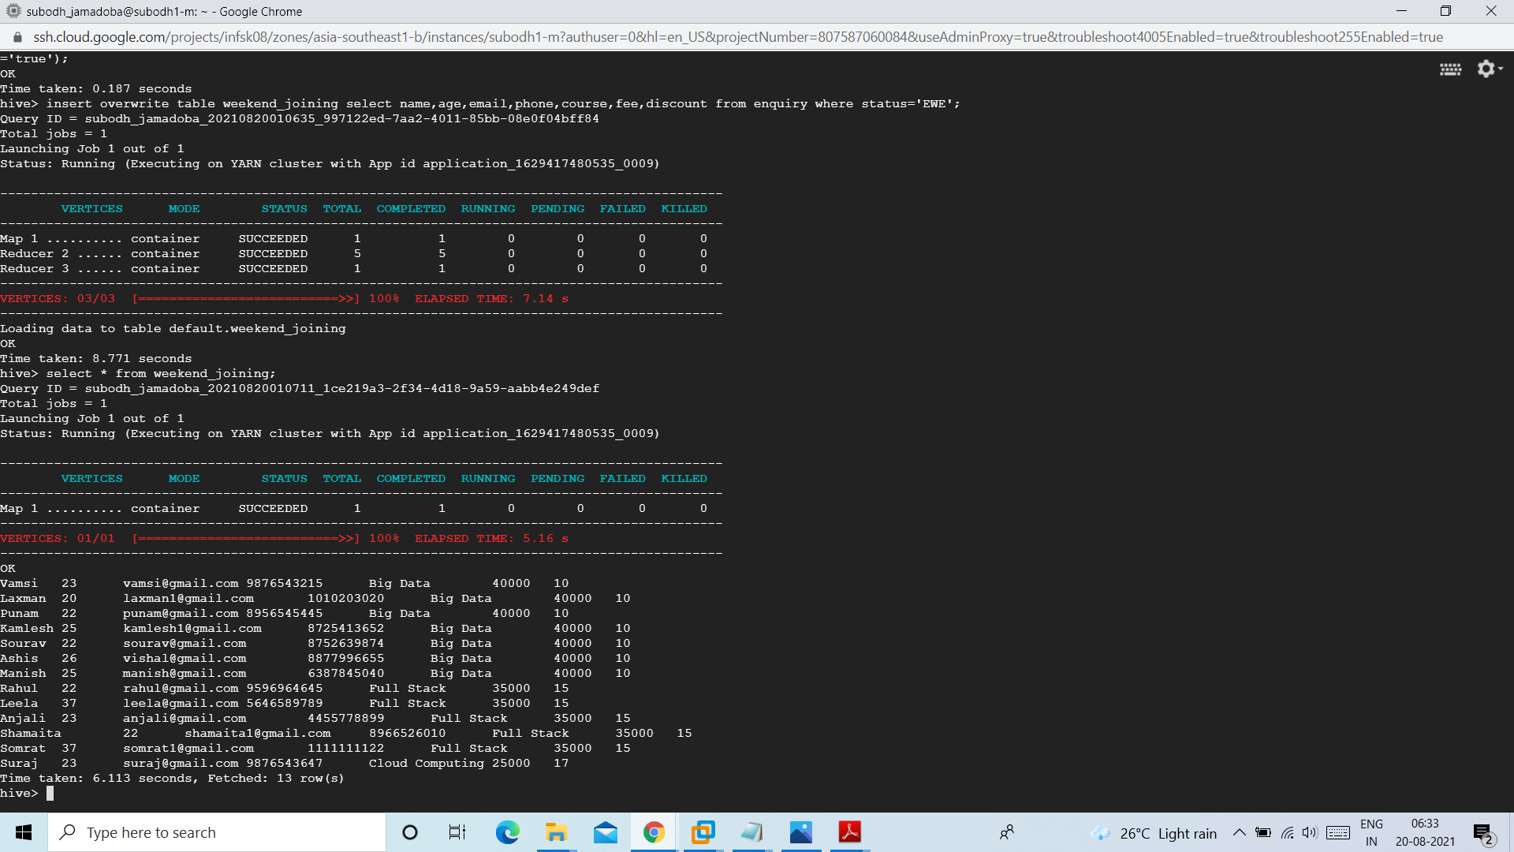

=>

create table not_joined(name string,age int,email string,phone string,course string,fee int,discount int,type string) clustered by(course) into 5 buckets stored as orc tblproperties('transactional'='true');

insert overwrite table not_joined select name,age,email,phone,course,fee,discount,case when substr(demo,1,2)=='WD' then 'Weekdays' else 'Weekend' end from enquiry where status='NJ';

Select * from not_joining;

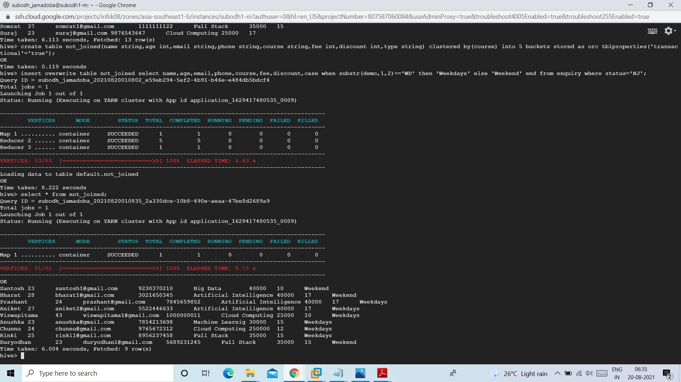

=>create table payment(name string,age int,email string,phone string,course string,type string,fee int) stored as orc tblproperties('transactional'='true');

insert overwrite table payment select name,age,email,phone,course,case when substr(demo,1,2)=='WD' then 'Weekdays' else 'Weekend' end,fee from enquiry where status='EWE' or status='EWD';

Select * from payment;

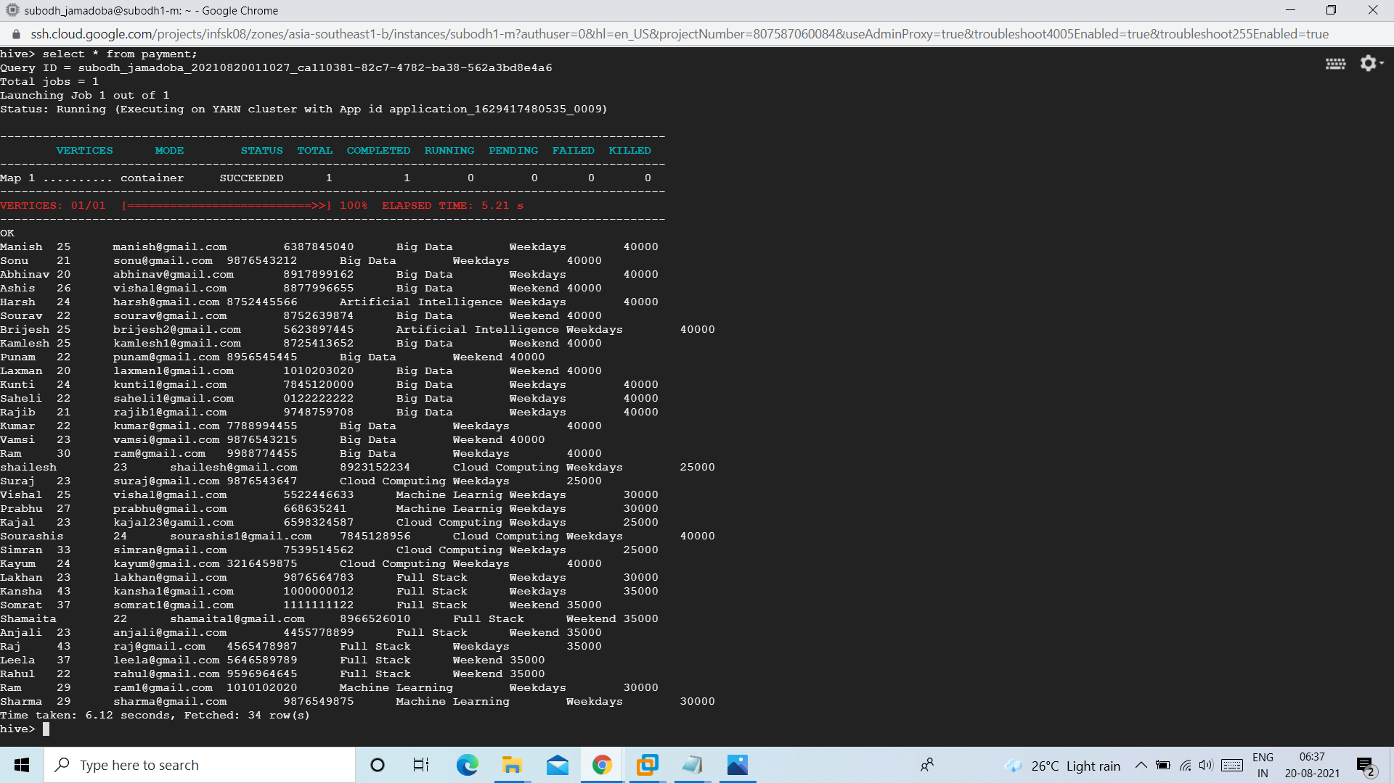

alter table payment add columns(paid int,mode string,no_of_install int,due_date string);

insert overwrite table payment select p.name, p.age, p.email, p.phone, p.course,p.type, p.fee,j.paid,j.mode,j.no_of_install,j.due_date from payment p left join table4 j on p.name=j.name;

insert overwrite table payment select p.name, p.age, p.email, p.phone, p.course,p.type, p.fee,j.paid,j.mode,j.no_of_install,j.due_date from payment p join table4 j on p.name=j.name;

Select * from payment;

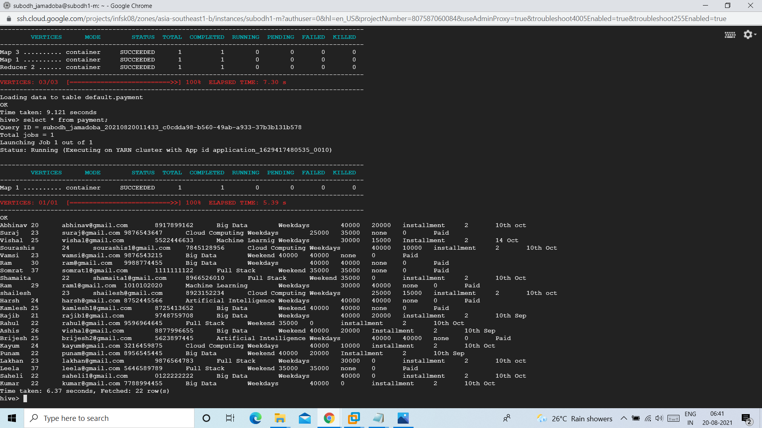

Let’s try to append a record to enquiry table and try to update it :

1. Inserting a new record into enquiry table

insert into table enquiry values("Ramesh",25,"Ramesh@gmail.com",'7869567860','Cloud Computing',25000,10,'WE:SUN:11AM','DND');

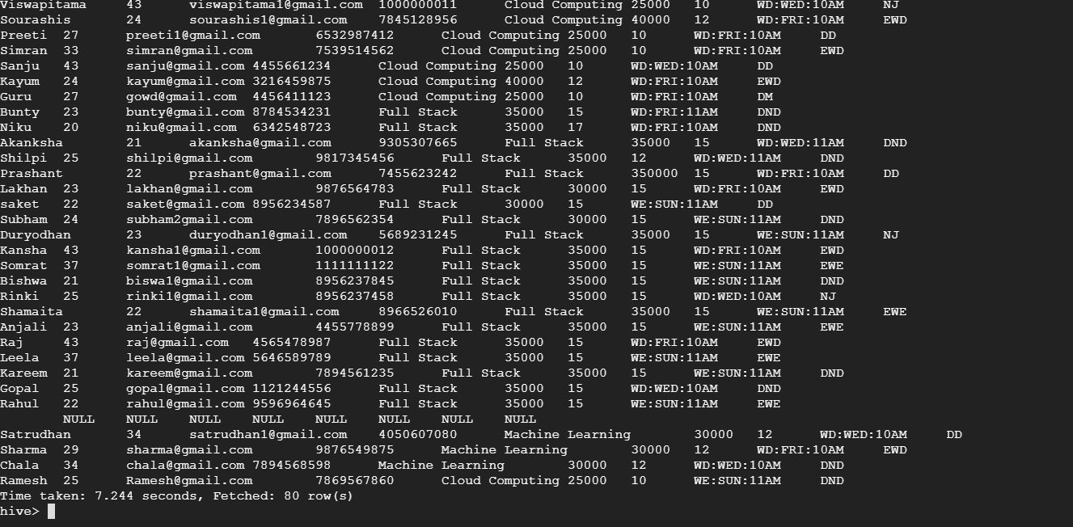

1. Fetching the record into Weekend_demo table

This can be done in two ways – we can insert the new record to our existing table or we can fetch the entire data who scheduled demo on Weekend from enquiry table

insert into table Weekend_demo values("Ramesh",25,"Ramesh@gmail.com",

'7869567860','Cloud Computing','SUN','11AM');

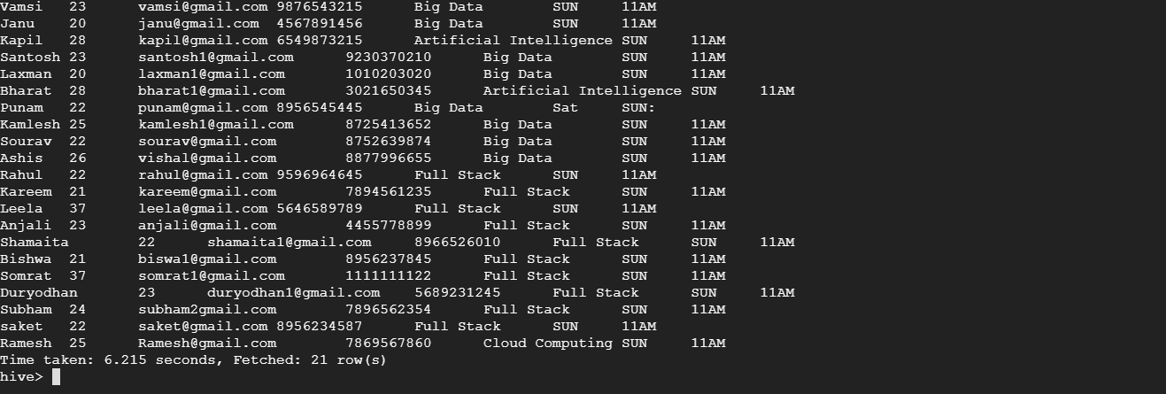

1. Now we assume that the new entry has done with demo and enrolled to Weekend course. We have to update the status to enquiry table

update enquiry set status='EWE' where name='Ramesh';

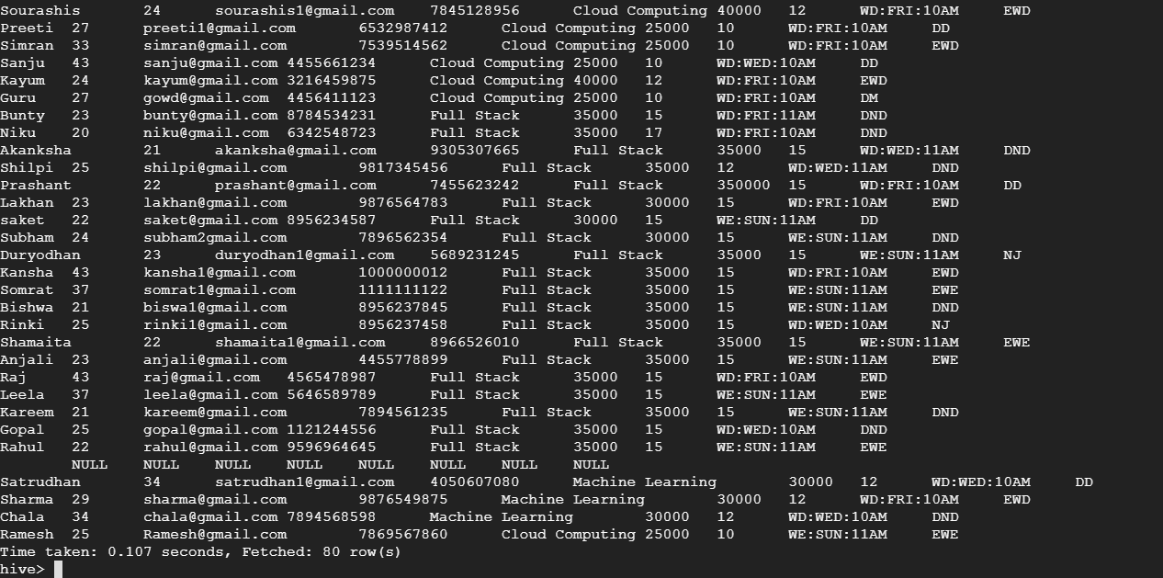

1. As the new entry is done with demo let’s delete the record from Weekend_demo table

delete from Weekend_demo where name='Ramesh';

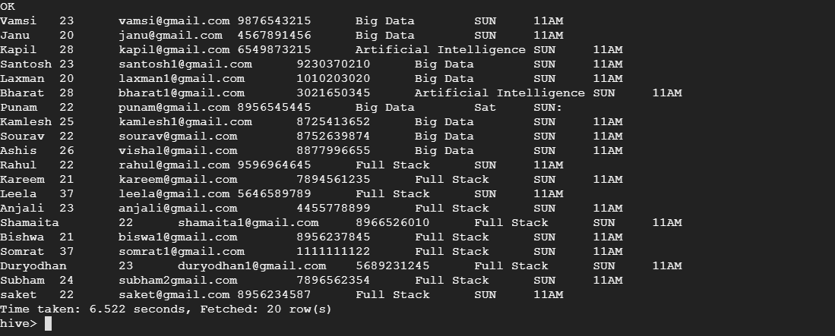

Queries Performed:

1. Students details who paid the fee

select * from payment where due_date='Paid';

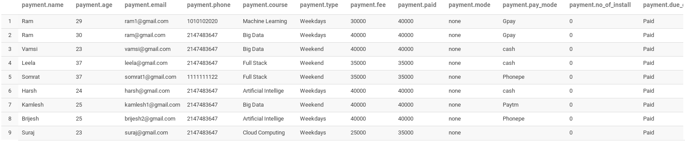

1. Student details who are not done with payment

select * from payment where due_date!='Paid';

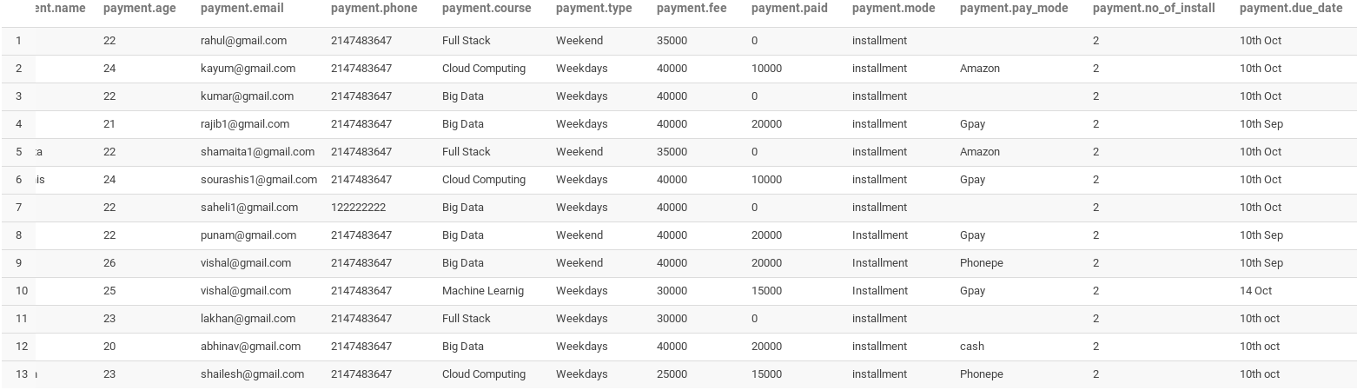

1. Student details who enrolled for Big Data in Weekend

select * from weekend_joining where course='Big Data';

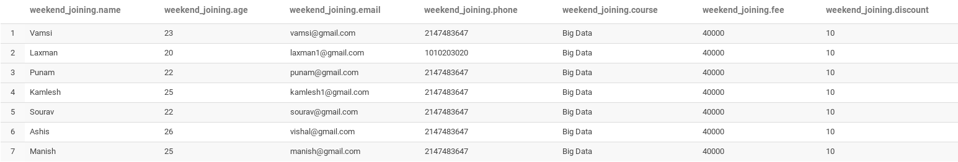

1. Student details who enrolled for Machine Learning course in Weekdays

select * from weekdays_joining where course='Machine Learning';



1. Student details who are enrolled for Full Stack in both Weekend and Weekdays

select * from enquiry where course='Full Stack' and (status='EWE' or status='EWD');

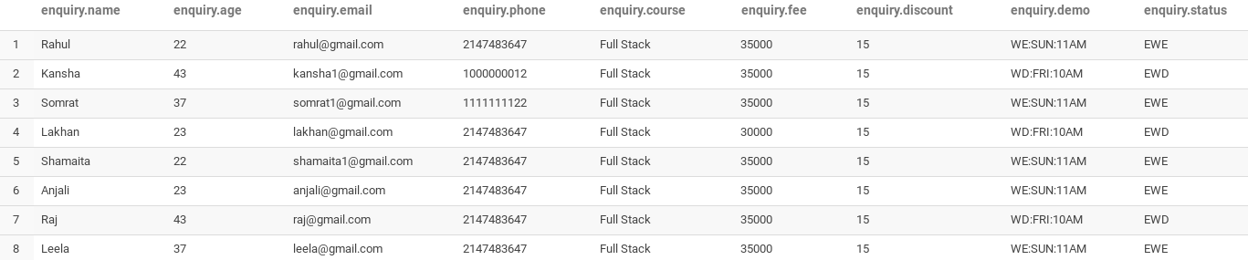

1. Find the number of students who have not joined the institute after completion of demo.

select count(*) from not_joined;

9

1. Student details who are opted for online payment mode.

select * from payment where pay_mode!='cash';

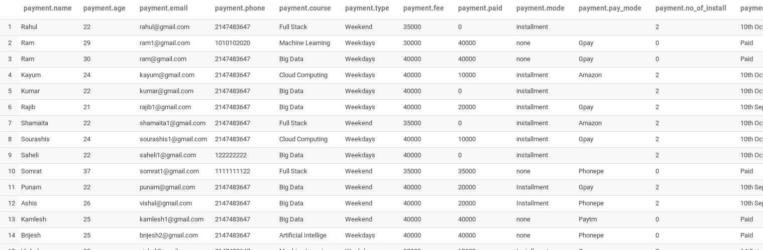

1. Query to extract courses and the number of students enrolled for each course.

select course,count(course) as cnt from enquiry where status='EWE' or status='EWD' group by course order by course;

Artificial Intelligence 2

Big Data 13

Cloud Computing 7

Full Stack 8

Machine Learning 3

1. Student details who have paid the more than half of the course fee

select * from payment where paid>=(fee/2);

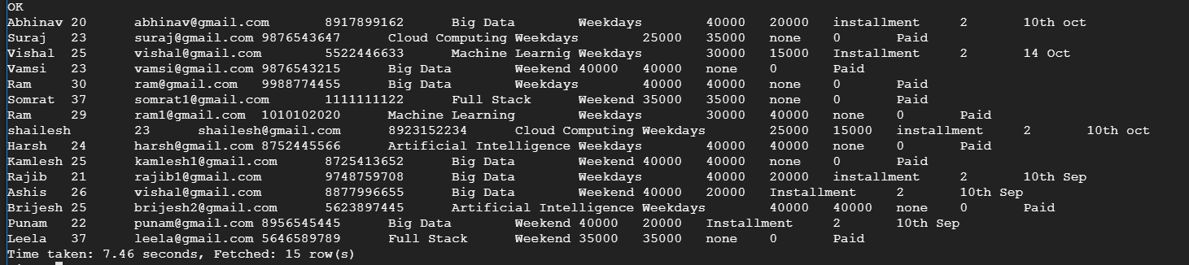

1. Query for the number of students missed the demo with respect to their courses.

select course,count(course) as cnt from demo_not_done group by course order by course;

Artificial Intelligence 2

Big Data 6

Cloud Computing 5

Full Stack 8

Machine Learning 1

1. Query to update student Eswar status to drop.

update enquiry set status='Drop' where name='Eswar';

select * from enquiry where name='Eswar';

Eswar 21 eswar@gmail.com 7780263965 Big Data 40000 10 WD:FRI:10AM Drop

1. Append a new record to enquiry table with demo scheduled on Thursday 10pm

insert into table enquiry values("Zakreen",26,"zak@gmail.com",'7865475634','Artificial Intelligence',35000,15,'WD:THURS:10PM','DND');

Zakreen 26 zak@gmail.com 7865475634 Artificial Intelligence 35000 15 WD:THURS:10PM DND

1. Display the names of the courses that are offering in the institute

select DISTINCT course from enquiry;

Artificial Intelligence

Big Data

Cloud Computing

Full Stack

Machine Learning

1. Extract the student details who have discount less than or equal 10

select * from enquiry where discount<=10;

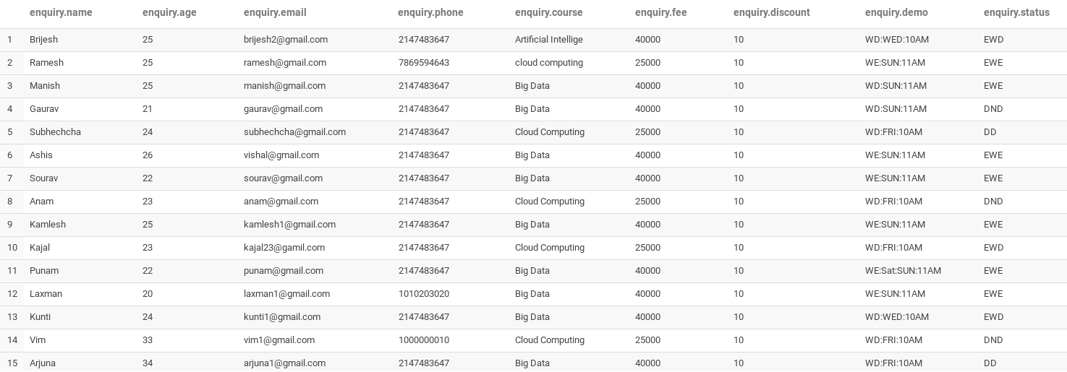

15. Students details who enrolled for course Big Datat

select * from weekend_joining where course='Big Data';

16. students who joined course cloud computing from weekend

select * from weekdays_joining where course='Cloud Computing';

17. students with age more than 24

select * from enquiry where age > 24;

18. students who having age more than 40 and from Big data course

select * from enquiry where age > 40 and course = 'Big Data';

18. students who got more than 10 % discount and age more than 22

select * from enquiry where discount<=10 and age >22;

19. all the course and their fee from enquiry table

select course,fee from equiry;

20. Query to find all the age groups enrolled and their count in descending order.

select age,count(age) from enquiry group by age order by age desc;

21.Query to extract the phone number of students who missed the demo

select phone from demo_not_done;

22. Query to extract the count of students missed demo based on the course

select course,count(course) from demo_not_done group by course;

23. Query to find the count of students missed the demo based on the week mode they opted.

select week, count(week) from demo_not_done group by week;

24. Students number who have joined in weekdays.

Select count (*) from weekday_joining

25. Demo scheduled on Sunday and is not done yet.

Select * from enquiry where substr(demo, 4, 3)=’SUN’ and status=’DND’;

26. Students have joined in weekdays and in Big Data Course

select * from weekdays_joining where course='Big Data';